

**SAHYADRI**

**COLLEGE OF ENGINEERING & MANAGEMENT**

**MANGALURU**

(Affiliated to VTU, Belagavi & Approved by AICTE, New Delhi)

**DEPARTMENT OF INFORMATION**

**SCIENCE & ENGINEERING**

**COMPUTER NETWORKS**

**LABORATORY MANUAL**

**18CSL57**

V Semester - BE

**DO'S AND DON’TS IN LABORATORY**

1. Remove footwear and keep it in the rack before entering the lab.

2. Make entry in the Log Book as soon as you enter the Laboratory.

3. All the students should sit according to their roll numbers starting from their left to right.

4. All the students are supposed to enter the terminal number in the log book.

5. Do not change the terminal on which you are working.

6. All the students are expected to get at least the algorithm of the program/concept to be

implemented.

7. Strictly observe the instructions given by the teacher/Lab Instructor.

8. The record should have following details:

a.Date

b.Aim

c.Algorithm

d.Program

e.Output

**CONTENTS**

|  |  |
| --- | --- |
| **PART A** | |
| 1 | Implement three nodes point – to – point network with duplex links between them. Set the queue size, vary the bandwidth and find the number of packets dropped. |
| 2 | Implement transmission of ping messages/trace route over a network topology consisting of 6 nodes and find the number of packets dropped due to congestion. |
| 3 | Implement an Ethernet LAN using n nodes and set multiple traffic nodes and plot congestion window for different source / destination. |
| 4 | Implement simple ESS and with transmitting nodes in wire-less LAN by simulation and determine the performance with respect to transmission of packets. |
| 5 | Implement and study the performance of GSM on NS2/NS3 (Using MAC layer) or equivalent environment. |
| 6 | Implement and study the performance of CDMA on NS2/NS3 (Using stack called Call net) or equivalent environment. |
| **PART B**  **Implement the following in Java:** | |
| 7 | Write a program for error detecting code using CRC-CCITT (16- bits). |
| 8 | Write a program to find the shortest path between vertices using bellman-ford algorithm. |
| 9 | Using TCP/IP sockets, write a client – server program to make the client send the file name and to make the server send back the contents of the requested file if present. |
| 10 | Write a program on datagram socket for client/server to display the messages on client side, typed at the server side. |
| 11 | Write a program for simple RSA algorithm to encrypt and decrypt the data. |
| 12 | Write a program for congestion control using leaky bucket algorithm. |

**Introduction to NS-2**

* Widely known as NS2, is simply an event driven simulation tool.
* Useful in studying the dynamic nature of communication networks.
* Simulation of wired as well as wireless network functions and protocols (e.g., routing algorithms, TCP, UDP) can be done using NS2.
* In general, NS2 provides users with a way of specifying such network protocols and simulating their corresponding behaviors.

**Basic Architecture of NS2**



**Tcl scripting**

• Tcl is a general purpose scripting language. [Interpreter]

• Tcl runs on most of the platforms such as Unix, Windows, and Mac.

• The strength of Tcl is its simplicity.

• It is not necessary to declare a data type for variable prior to the usage.

**Basics of TCL**

Syntax: command arg1 arg2 arg3

* **Hello World!**

puts stdout{Hello, World!}

Hello, World!

* **Variables** Command Substitution

set a 5 set len [string length foobar]

set b $a set len [expr [string length foobar] + 9]

* **Simple Arithmetic**

expr 7.2 / 4

* **Procedures**

proc Diag {a b} {

set c [expr sqrt($a * $a + $b * $b)]

return $c }

puts “Diagonal of a 3, 4 right triangle is [Diag 3 4]”

Output: Diagonal of a 3, 4 right triangle is 5.0

* **Loops**

while{$i < $n} { for {set i 0} {$i < $n} {incr i} {

. . . . . .

} }

**Wired TCL Script Components**

Create the event scheduler

Open new files & turn on the tracing

Create the nodes

Setup the links

Configure the traffic type (e.g., TCP, UDP, etc)

Set the time of traffic generation (e.g., CBR, FTP)

Terminate the simulation

**NS Simulator Preliminaries.**

1. Initialization and termination aspects of the ns simulator.

2. Definition of network nodes, links, queues and topology.

3. Definition of agents and of applications.

4. The nam visualization tool.

5. Tracing and random variables.

**Initialization and Termination of TCL Script in NS-2**

An ns simulation starts with the command

**set ns [new Simulator]**

Which is thus the first line in the tcl script? This line declares a new variable as using the set command, you can call this variable as you wish, In general people declares it as ns because it is an instance of the Simulator class, so an object the code[new Simulator] is indeed the installation of the class Simulator using the reserved word new.

In order to have output files with data on the simulation (trace files) or files used for visualization (nam files), we need to create the files using “open” command:

**#Open the Trace file**

**set tracefile1 [open out.tr w]**

**$ns trace-all $tracefile1**

**#Open the NAM trace file**

**set namfile [open out.nam w]**

**$ns namtrace-all $namfile**

The above creates a dta trace file called ”out.tr” and a nam visualization trace file called ”out.nam”.

Within the tcl script, these files are not called explicitly by their names, but instead by pointers that are declared above and called “tracefile1” and “namfile” respectively. Remark that they begins with a # symbol. The second line open the file “out.tr” to be used for writing, declared with the letter “w”. The third line uses a simulator method called trace-all that have as parameter the name of the file where the traces will go. The last line tells the simulator to record all simulation traces in NAM input format. It also gives the file name that the trace will be written to later by the command $ns flush-trace.In our case,this will be the file pointed at by the pointer “$namfile”, i.e the file “out.tr”. The termination of the program is done using a “finish” procedure.

**#Define a ”finish” procedure**

**Proc finish { } {**

**global ns tracefile1 namfile**

**$ns flush-trace**

**Close $tracefile1**

**Close $namfile**

**Exec nam out.nam &**

**Exit 0**

**}**

The word proc declares a procedure in this case called **finish** and without arguments. The word **global** is used to tell that we are using variables declared outside the procedure.

The simulator method “**flush-trace”** will dump the traces on the respective files. The tcl command “**close”** closes the trace files defined before and **exec** executes the nam program for visualization. The command **exit** will ends the application and return the number 0 as status to the system. Zero is the default for a clean exit. Other values can be used to say that is a exit because something fails.

At the end of ns program we should call the procedure “finish” and specify at what time the termination should occur. For example,

**$ns at 125.0 “finish”**

Above script will be used to call “**finish**” at time 125sec.Indeed,the **at** method of the simulator allows us to schedule events explicitly.

The simulation can then begin using the command

**$ns run**

**Definition of a network of links and nodes**

The way to define a node is

**set n0 [$ns node]**

The node is created which is printed by the variable n0. When we shall refer to that node in the script we shall thus write $n0.

Once we define several nodes, we can define the links that connect them. An example of a definition of a link is:

**$ns duplex-link $n0 $n2 10Mb 10ms DropTail**

Which means that $n0 and $n2 are connected using a bi-directional link that has 10ms of propagation delay and a capacity of 10Mb per sec for each direction.

To define a directional link instead of a bi-directional one, we should replace “duplex-link” by “simplex-link”. In NS, an output queue of a node is implemented as a part of each link whose input is that node. The definition of the link then includes the way to handle overflow at that queue. In our case, if the buffer capacity of the output queue is exceeded then the last packet to arrive is dropped. Many alternative options exist, such as the RED (Random Early Discard) mechanism, the FQ (Fair Queuing), the DRR (Deficit Round Robin), the stochastic Fair Queuing (SFQ) and the CBQ (which including a priority and a round-robin scheduler).

In ns, an output queue of a node is implemented as a part of each link whose input is that node. We should also define the buffer capacity of the queue related to each link. An example would be:

**#set Queue Size of link (n0-n2) to 20**

**$ns queue-limit $n0 $n2 20**

**Agents and Applications**

We need to define routing (sources, destinations) the agents (protocols) the application that use them.

**FTP over TCP**

TCP is a dynamic reliable congestion control protocol. It uses Acknowledgements created by the destination to know whether packets are well received.

There are number variants of the TCP protocol, such as Tahoe, Reno, NewReno, Vegas. The type of agent appears in the first line:

**set tcp [new Agent/TCP]**

The command **$ns attach-agent $n0 $tcp** defines the source node of the tcp connection. The command

**set sink [new Agent /TCPSink**]

Defines the behavior of the destination node of TCP and assigns to it a pointer called sink.

**#Setup a UDP connection**

**set udp [new Agent/UDP]**

**$ns attach-agent $n1**

**$udp set null [new Agent/Null]**

**$ns attach-agent $n5 $null**

**$ns connect $udp $null**

**$udp set fid_2**

**#Setup a CBR over UDP connection**

The below shows the definition of a CBR application using a UDP agent The command **$ns attach-agent $n4 $sink** defines the destination node.

The command **$ns connect $tcp $sink** finally makes the TCP connection between the source and destination nodes.

**set cbr [new Application/Traffic/CBR]**

**$cbr attach-agent $udp**

**$cbr set packetsize_ 100**

**$cbr set rate_ 0.01Mb**

**$cbr set random_ false**

TCP has many parameters with initial fixed defaults values that can be changed if mentioned explicitly. For example, the default TCP packet size has a size of 1000bytes.This can be changed to another value, say 552bytes, using the command **$tcp set packetSize_ 552**.

When we have several flows, we may wish to distinguish them so that we can identify them with different colors in the visualization part. This is done by the command **$tcp set fid_ 1** that assigns to the TCP connection a flow identification of “1”.We shall later give the flow identification of “2” to the UDP connection.

**CBR over UDP**

A UDP source and destination is defined in a similar way as in the case of TCP.

Instead of defining the rate in the command $cbr set rate_ 0.01Mb, one can define the time interval between transmission of packets using the command.

**$cbr set interval_ 0.005**

The packet size can be set to some value using

**$cbr set packetSize_ <packet size>**

**Scheduling Events**

NS is a discrete event based simulation. The tcp script defines when event should occur. The initializing command set ns [new Simulator] creates an event scheduler, and events are then scheduled using the format:

**$ns at <time><event>**

The scheduler is started when running ns that is through the command $ns run. The beginning and end of the FTP and CBR application can be done through the following command

**$ns at 0.1 “$cbr start”**

**$ns at 1.0 “ $ftp start”**

**$ns at 124.0 “$ftp stop”**

**$ns at 124.5 “$cbr stop”**

**Structure of Trace Files**

When tracing into an output ASCII file, the trace is organized in 12 fields as follows in fig shown below, The meaning of the fields are:

|  |  |  |  |  |  |  |  |  |  |  |  |
| --- | --- | --- | --- | --- | --- | --- | --- | --- | --- | --- | --- |
| Event | Time | From Node | To Node | PKT Type | PKT Size | Flags | Fid | Src Addr | Dest Addr | Seq Num | Pkt id |

|  |
| --- |
| 1. The first field is the event type. It is given by one of four possible symbols r, +, -, d which correspond respectively to receive (at the output of the link), enqueued, dequeued and dropped. |
| 2. The second field gives the time at which the event occurs. |
| 3. Gives the input node of the link at which the event occurs. |
| 4. Gives the output node of the link at which the event occurs. |
| 5. Gives the packet type (eg CBR or TCP) |
| 6. Gives the packet size |
| 7. Some flags |
| 8. This is the flow id (fid) of IPv6 that a user can set for each flow at the input OTcl script one can further use this field for analysis purposes; it is also used when specifying stream color for the NAM display. |
| 9. This is the source address given in the form of ―node.port‖. |
| 10. This is the destination address, given in the same form. |
| 11. This is the network layer protocol‘s packet sequence number. Even though UDP implementations in a real network do not use sequence number, ns keeps track of UDP packet sequence number for analysis purposes |
| 12. The last field shows the unique id of the packet. |

**XGRAPH**

The xgraph program draws a graph on an x-display given data read from either data file or from standard input if no files are specified. It can display upto 64 independent data sets using different colors and line styles for each set. It annotates the graph with a title, axis labels, grid lines or tick marks, grid labels and a legend.

**Syntax:**

**Xgraph [options] file-name**

Options are listed here

**/-bd <color> (Border)**

This specifies the border color of the xgraph window.

**/-bg <color> (Background)**

This specifies the background color of the xgraph window.

**/-fg<color> (Foreground)**

This specifies the foreground color of the xgraph window.

**/-lf <fontname> (LabelFont)**

All axis labels and grid labels are drawn using this font.

**/-t<string> (Title Text)**

This string is centered at the top of the graph.

**/-x <unit name> (XunitText)**

This is the unit name for the x-axis. Its default is “X”.

**/-y <unit name> (YunitText)**

This is the unit name for the y-axis. Its default is “Y”.

**Awk- An Advanced**

Awk is a programmable, pattern-matching, and processing tool available in UNIX. It works equally well with text and numbers.

Awk is not just a command, but a programming language too. In other words, awk utility is a pattern scanning and processing language. It searches one or more files to see if they contain lines that match specified patterns and then perform associated actions, such as writing the line to the standard output or incrementing a counter each time it finds a match.

Syntax:

**awk option ‘selection_criteria {action}’ file(s)**

Here, selection_criteria filters input and select lines for the action component to act upon. The selection_criteria is enclosed within single quotes and the action within the curly braces. Both the selection_criteria and action forms an awk program.

**Example: $ awk „/manager/ {print}‟ emp.lst**

**Variables**

Awk allows the user to use variables of there choice. You can now print a serial number, using the variable kount, and apply it those directors drawing a salary exceeding 6700:

**$ awk –F”|” „$3 == “director” && $6 > 6700 {**

**kount =kount+1**

**printf “ %3f %20s %-12s %d\n”, kount,$2,$3,$6 }‟ empn.lst**

**THE –f OPTION: STORING awk PROGRAMS IN A FILE**

You should holds large awk programs in separate file and provide them with the awk extension for easier identification. Let‘s first store the previous program in the file empawk.awk:

**$ cat empawk.awk**

Observe that this time we haven‘t used quotes to enclose the awk program. You can now use awk with the –f *filename* option to obtain the same output:

**Awk –F”|” –f empawk.awk empn.lst**

**THE BEGIN AND END SECTIONS**

Awk statements are usually applied to all lines selected by the address, and if there are no addresses, then they are applied to every line of input. But, if you have to print something before processing the first line, for example, a heading, then the BEGIN section can be used gainfully. Similarly, the end section useful in printing some totals after processing is over. The BEGIN and END sections are optional and take the form

**BEGIN {action}**

**END {action}**

These two sections, when present, are delimited by the body of the awk program. You can use them to print a suitable heading at the beginning and the average salary at the end.

**BUILT-IN VARIABLES**

Awk has several built-in variables. They are all assigned automatically, though it is also possible for a user to reassign some of them. You have already used NR, which signifies the record number of the current line. We‘ll now have a brief look at some of the other variable.

***The FS Variable****:* as stated elsewhere, awk uses a contiguous string of spaces as the default field delimiter. FS redefines this field separator, which in the sample database happens to be the |. When used at all, it must occur in the BEGIN section so that the body of the program knows its value before it starts processing:

**BEGIN {FS=”|”}**

This is an alternative to the –F option which does the same thing.

***The OFS Variable****:* when you used the print statement with comma-separated arguments, each argument was separated from the other by a space. This is awk‘s default output field separator, and can reassigned using the variable OFS in the BEGIN section: **BEGIN { OFS=”~” }**

When you reassign this variable with a ~ (tilde), awk will use this character for delimiting the print arguments. This is a useful variable for creating lines with delimited fields.

***The NF variable****:* NF comes in quite handy for cleaning up a database of lines that don‘t contain the right number of fields. By using it on a file, say emp.lst, you can locate those lines not having 6 fields, and which have crept in due to faulty data entry:

**$awk „BEGIN {FS = “|”}**

**NF! =6 {**

**Print “Record No “, NR, “has”, “fields”}‟ empx.lst**

**1. Implement three nodes point – to – point network with duplex links between them. Set the queue size, vary the bandwidth and find the number of packets dropped.**

**Theory:**



**Program:**

**1.tcl**

# This script is created by NSG2 beta1

# <http://wushoupong.googlepages.com/nsg>

#===================================

# Simulation parameters setup

#===================================

set val(stop) 10.0 ;# time of simulation end

#===================================

# Initialization

#===================================

#Create a ns simulator

set ns [new Simulator]

#Open the NS trace file

set tracefile [open 1.tr w]

$ns trace-all $tracefile

#Open the NAM trace file

set namfile [open 1.nam w]

$ns namtrace-all $namfile

#===================================

# Nodes Definition

#===================================

#Create 3 nodes

set n0 [$ns node]

set n1 [$ns node]

set n2 [$ns node]

#===================================

# Links Definition

#===================================

#Createlinks between nodes

$ns duplex-link $n0 $n1 **1000.0Kb 10ms** DropTail

$ns queue-limit $n0 $n1 **5**

$ns duplex-link $n1 $n2 **1000.0Kb 10ms** DropTail

$ns queue-limit $n1 $n2 **3**

#Give node position (for NAM)

$ns duplex-link-op $n0 $n1 orient right-up

$ns duplex-link-op $n1 $n2 orient right-down

#===================================

# Agents Definition

#===================================

#Setup a TCP/Vegas connection

set tcp0 [new Agent/TCP/Vegas]

$ns attach-agent $n0 $tcp0

set sink1 [new Agent/TCPSink]

$ns attach-agent $n2 $sink1

$ns connect $tcp0 $sink1

$tcp0 set packetSize_ 1500

#===================================

# Applications Definition

#===================================

#Setup a FTP Application over TCP/Vegas connection

set ftp0 [new Application/FTP]

$ftp0 attach-agent $tcp0

$ns at 1.0 "$ftp0 start"

$ns at 2.0 "$ftp0 stop"

**$ns at 10.0 "finish"**

#===================================

# Termination

#===================================

#Define a 'finish' procedure

proc finish {} {

global ns tracefile namfile

$ns flush-trace

close $tracefile

close $namfile

exec nam 5.nam &

exit 0

}

$ns at $val(stop) "$ns nam-end-wireless $val(stop)"

$ns at $val(stop) "finish"

$ns at $val(stop) "puts \"done\" ; $ns halt"

$ns run

**1.awk**

BEGIN{

count=0;

total=0;

}

{

event = $1;

if(event == "d")

{

count++;

}}

END{

printf("No of packets droped: %d\n",count);

}

**Execution and Output:**

[student@student-Veriton-Series:~/ns2$ java -jar nsg2.1.jar



[student@student-Veriton-Series:~/ns2$ ns 1.tcl

[student@student-Veriton-Series:~/ns2$ gedit 1.awk

[student@student-Veriton-Series:~/ns2$ awk -f 1.awk 1.tr

**No of packets droped: 3**

|  |  |  |  |  |  |  |  |
| --- | --- | --- | --- | --- | --- | --- | --- |
| Sl.No. | Data rate | | Propagation Delay | | Queue Limit | | Packets  Dropped |
| n0-n1 | n1-n2 | n0-n1 | n1-n2 | n0-n1 | n1-n2 |  |
| 1 | 1000.0Kb | 1000.0Kb | 10ms | 10ms | 5 | 3 | 3 |
| 2 |  |  |  |  |  |  |  |
| 3 |  |  |  |  |  |  |  |
| 4 |  |  |  |  |  |  |  |

**Nam file Window:**



**2. Implement transmission of ping messages/trace route over a network topology consisting of 6 nodes and find the number of packets dropped due to congestion.**

**Thoery:**



**Program:**

**2.tcl**

# This script is created by NSG2 beta1

# <http://wushoupong.googlepages.com/nsg>

#===================================

# Simulation parameters setup

#===================================

set val(stop) 10.0 ;# time of simulation end

#===================================

#Initialization

#===================================

#Create a ns simulator

set ns [new Simulator]

#Open the NS trace file

set tracefile [open 2.tr w]

$ns trace-all $tracefile

#Open the NAM trace file

set namfile [open 2.nam w]

$ns namtrace-all $namfile

$ns color 1 Blue

$ns color 2 Red

#===================================

# Nodes Definition

#===================================

#Create 7 nodes

set n0 [$ns node]

set n1 [$ns node]

set n2 [$ns node]

set n3 [$ns node]

set n4 [$ns node]

set n5 [$ns node]

set n6 [$ns node]

#===================================

# Links Definition

#===================================

#Createlinks between nodes

$ns duplex-link $n0 $n1 **1Mb 50ms** DropTail

$ns queue-limit $n0 $n1 **50**

$ns duplex-link $n0 $n3 **1Mb 50ms** DropTail

$ns queue-limit $n0 $n3 **50**

$ns duplex-link $n0 $n4 **1Mb 50ms** DropTail

$ns queue-limit $n0 $n4 **50**

$ns duplex-link $n0 $n5 **1Mb 50ms** DropTail

$ns queue-limit $n0 $n5 **2**

$ns duplex-link $n0 $n2 **1Mb 50ms** DropTail

$ns queue-limit $n0 $n2 **2**

$ns duplex-link $n0 $n6 **1Mb 50ms** DropTail

$ns queue-limit $n0 $n6 **1**

#Give node position (for NAM)

$ns duplex-link-op $n0 $n1 orient left-up

$ns duplex-link-op $n0 $n4 orient right-down

$ns duplex-link-op $n0 $n2 orient right-up

$ns duplex-link-op $n0 $n3 orient right

$ns duplex-link-op $n0 $n5 orient left-down

$ns duplex-link-op $n0 $n6 orient left

**Agent/Ping instproc recv {from rtt} {**

**$self instvar node_**

**puts "node [$node_ id] received ping answer $from with round-trip-time $rtt ms."**

**}**

**set p1 [new Agent/Ping]**

**set p2 [new Agent/Ping]**

**set p3 [new Agent/Ping]**

**set p4 [new Agent/Ping]**

**set p5 [new Agent/Ping]**

**set p6 [new Agent/Ping]**

**$ns attach-agent $n1 $p1**

**$ns attach-agent $n2 $p2**

**$ns attach-agent $n3 $p3**

**$ns attach-agent $n4 $p4**

**$ns attach-agent $n5 $p5**

**$ns attach-agent $n6 $p6**

**$ns connect $p1 $p4**

**$ns connect $p2 $p5**

**$ns connect $p3 $p6**

**$ns at 0.2 "$p1 send"**

**$ns at 0.4 "$p2 send"**

**$ns at 0.6 "$p3 send"**

**$ns at 1.0 "$p4 send"**

**$ns at 1.2 "$p5 send"**

**$ns at 1.4 "$p6 send"**

**$ns at 10.0 "finish"**

#===================================

# Agents Definition

#===================================

#===================================

# Applications Definition

#===================================

#===================================

# Termination

#===================================

#Define a 'finish' procedure

proc finish {} {

global ns tracefile namfile

$ns flush-trace

close $tracefile

close $namfile

exec nam 2.nam &

exit 0

}

$ns at $val(stop) "$ns nam-end-wireless $val(stop)"

$ns at $val(stop) "finish"

$ns at $val(stop) "puts \"done\" ; $ns halt"

$ns run

**2.awk:**

BEGIN{

count=0;

}

{

event=$1;

if(event=="d")

{

count++;

}

}

END{

printf("No.of packets dropped:%d\n",count);

}

**Execution and Output:**

[student@student-Veriton-Series:~/ns2$ java -jar nsg2.1.jar



[student@student-Veriton-Series:~/ns2$ ns 2.tcl

**node 1 received ping answer 4 with round-trip-time 202.0 ms.**

**node 2 received ping answer 5 with round-trip-time 202.0 ms.**

**node 4 received ping answer 1 with round-trip-time 202.0 ms.**

**node 5 received ping answer 2 with round-trip-time 202.0 ms.**

[student@student-Veriton-Series:~/ns2$ gedit 2.awk

[student@student-Veriton-Series:~/ns2$ awk -f 2.awk 2.tr

**No of packets droped: 2**

**Nam file window:**



**3. Implement an Ethernet LAN using n nodes and set multiple traffic nodes and plot**

**congestion window for different source / destination.**

**3.tcl:**

# This script is created by NSG2 beta1

# <http://wushoupong.googlepages.com/nsg>

#===================================

# Simulation parameters setup

#===================================

set val(stop) 10.0 ;# time of simulation end

#===================================

# Initialization

#===================================

#Create a ns simulator

set ns [new Simulator]

#Open the NS trace file

set tracefile [open 3.tr w]

$ns trace-all $tracefile

#Open the NAM trace file

set namfile [open 3.nam w]

$ns namtrace-all $namfile

**$ns color 1 Blue**

**$ns color 2 Red**

#===================================

# Nodes Definition

#===================================

#Create 9 nodes

set n0 [$ns node]

set n1 [$ns node]

set n2 [$ns node]

set n3 [$ns node]

set n4 [$ns node]

set n5 [$ns node]

set n6 [$ns node]

set n7 [$ns node]

set n8 [$ns node]

**$ns make-lan "$n3 $n4 $n5 $n6 $n7 $n8" 512Kb 50ms LL Queue/DropTail**

#===================================

# Links Definition

#===================================

#Createlinks between nodes

$ns duplex-link $n1 $n0 2.0Mb 50ms DropTail

$ns queue-limit $n1 $n0 50

$ns duplex-link $n2 $n0 2.0Mb 50ms DropTail

$ns queue-limit $n2 $n0 50

$ns duplex-link $n0 $n3 1.0Mb 50ms DropTail

$ns queue-limit $n0 $n3 7

#Give node position (for NAM)

$ns duplex-link-op $n1 $n0 orient right-up

$ns duplex-link-op $n2 $n0 orient right-down

$ns duplex-link-op $n0 $n3 orient right

#===================================

# Agents Definition

#===================================

#Setup a TCP/Reno connection

set tcp0 [new Agent/TCP/Reno]

$ns attach-agent $n1 $tcp0

set sink3 [new Agent/TCPSink]

$ns attach-agent $n7 $sink3

$ns connect $tcp0 $sink3

$tcp0 set packetSize_ 1500

**$tcp0 set class_ 1**

**set tfile1 [open cwnd1.tr w]**

**$tcp0 attach $tfile1**

**$tcp0 trace cwnd_**

#Setup a TCP/Vegas connection

set tcp1 [new Agent/TCP/Vegas]

$ns attach-agent $n2 $tcp1

set sink2 [new Agent/TCPSink]

$ns attach-agent $n4 $sink2

$ns connect $tcp1 $sink2

$tcp1 set packetSize_ 1500

**$tcp1 set class_ 2**

**set tfile2 [open cwnd2.tr w]**

**$tcp1 attach $tfile2**

**$tcp1 trace cwnd_**

#===================================

# Applications Definition

#===================================

#Setup a FTP Application over TCP/Vegas connection

set ftp0 [new Application/FTP]

$ftp0 attach-agent $tcp1

$ns at **0.3**"$ftp0 start"

$ns at **8.0**"$ftp0 stop"

#Setup a FTP Application over TCP/Reno connection

set ftp1 [new Application/FTP]

$ftp1 attach-agent $tcp0

$ns at **0.3**"$ftp1 start"

$ns at **8.0**"$ftp1 stop"

**$ns at 10.0 "finish"**

#===================================

# Termination

#===================================

#Define a 'finish' procedure

proc finish {} {

global ns tracefile namfile

$ns flush-trace

close $tracefile

close $namfile

exec nam 3.nam &

exit 0

}

$ns at $val(stop) "$ns nam-end-wireless $val(stop)"

$ns at $val(stop) "finish"

$ns at $val(stop) "puts \"done\" ; $ns halt"

$ns run

**3.awk:**

BEGIN{

}

{

if($6=="cwnd_")

{

printf("%f\t%f\n",$1,$7);

}

}

END{

}

**Execution:**

[student@student-Veriton-Series:~/ns2$ java -jar nsg2.1.jar



student@student-Veriton-Series:~/ns2$ ns 3.tcl

student@student-Veriton-Series:~/ns2$ gedit 3.awk

student@student-Veriton-Series:~/ns2$ awk -f 3.awk cwnd1.tr>out3a

student@student-Veriton-Series:~/ns2$ xgraph out3a

student@student-Veriton-Series:~/ns2$ awk -f 3.awk cwnd2.tr>out3b

student@student-Veriton-Series:~/ns2$ xgraph out3b

student@student-Veriton-Series:~/ns2$ xgraph out3a out3b



**Nam file window:**



**4. Implement simple ESS and with transmitting nodes in wire-less LAN by simulation**

**and determine the performance with respect to transmission of packets.**

**4.tcl**

# This script is created by NSG2 beta1

# <http://wushoupong.googlepages.com/nsg>

#===================================

# Simulation parameters setup

#===================================

set val(chan) Channel/WirelessChannel ;# channel type

set val(prop) Propagation/TwoRayGround ;# radio-propagation model

set val(netif) Phy/WirelessPhy ;# network interface type

set val(mac) Mac/802_11 ;# MAC type

set val(ifq) Queue/DropTail/PriQueue ;# interface queue type

set val(ll) LL ;# link layer type

set val(ant) Antenna/OmniAntenna ;# antenna model

set val(ifqlen) 50 ;# max packet in ifq

set val(nn) 2 ;# number of mobilenodes

set val(rp) DSDV ;# routing protocol

set val(x) **700** ;# X dimension of topography

set val(y) **444** ;# Y dimension of topography

set val(stop) 10.0 ;# time of simulation end

#===================================

# Initialization

#===================================

#Create a ns simulator

set ns [new Simulator]

#Setup topography object

set topo [new Topography]

$topo load_flatgrid $val(x) $val(y)

create-god $val(nn)

#Open the NS trace file

set tracefile [open 4.tr w]

$ns trace-all $tracefile

#Open the NAM trace file

set namfile [open 4.nam w]

$ns namtrace-all $namfile

$ns namtrace-all-wireless $namfile $val(x) $val(y)

set chan [new $val(chan)];#Create wireless channel

#===================================

# Mobile node parameter setup

#===================================

$ns node-config -adhocRouting $val(rp) \

-llType $val(ll) \

-macType $val(mac) \

-ifqType $val(ifq) \

-ifqLen $val(ifqlen) \

-antType $val(ant) \

-propType $val(prop) \

-phyType $val(netif) \

-channel $chan \

-topoInstance $topo \

-agentTrace ON \

-routerTrace ON \

-macTrace ON \

-movementTrace ON

#===================================

# Nodes Definition

#===================================

#Create 2 nodes

set n0 [$ns node]

$n0 set X_ **268**

$n0 set Y_ **339**

$n0 set Z_ 0.0

$ns initial_node_pos $n0 20

set n1 [$ns node]

$n1 set X_ **428**

$n1 set Y_ **344**

$n1 set Z_ 0.0

$ns initial_node_pos $n1 20

**$ns at .1 "$n0 setdest 600 344 100"**

**$ns at .1 "$n1 setdest 300 339 100"**

#===================================

# Agents Definition

#===================================

#Setup a TCP connection

set tcp0 [new Agent/TCP]

$ns attach-agent $n0 $tcp0

set sink1 [new Agent/TCPSink]

$ns attach-agent $n1 $sink1

$ns connect $tcp0 $sink1

$tcp0 set packetSize_ 1500

#===================================

# Applications Definition

#===================================

#Setup a FTP Application over TCP connection

set ftp0 [new Application/FTP]

$ftp0 attach-agent $tcp0

$ns at 1.0 "$ftp0 start"

$ns at 5.0 "$ftp0 stop"

**$ns at 10.0 "finish"**

#===================================

# Termination

#===================================

#Define a 'finish' procedure

proc finish {} {

global ns tracefile namfile

$ns flush-trace

close $tracefile

close $namfile

exec nam 4.nam &

exit 0

}

for {set i 0} {$i < $val(nn) } { incr i } {

$ns at $val(stop) "\$n$i reset"

}

$ns at $val(stop) "$ns nam-end-wireless $val(stop)"

$ns at $val(stop) "finish"

$ns at $val(stop) "puts \"done\" ; $ns halt"

$ns run

**4.awk:**

BEGIN{

count1=0;

fack1=0;

time1=0;

}

{

if($1==”r” && $3==”1” && $4==”AGT”)

{

count1++;

fack1= fack1+$8;

time1=$2;

}

}

END{

printf(“The throughput from n0 to n1 : %f Mbps\n”,((count1*fack1*8)/(time1*1024)));

}

**Execution:**

student@student-Veriton-Series:~/ns2$ java -jar nsg2.1.jar



student@student-Veriton-Series:~/ns2$ ns 4.tcl

student@student-Veriton-Series:~/ns2$ gedit 4.awk

student@student-Veriton-Series:~/ns2$ awk –f 4.awk 4.tr

**The throughput from n0 to n1 : 97.158654 Mbps**

**Nam file window:**



**5. Implement and study the performance of GSM on NS2/NS3 (Using MAC layer) or equivalent environment.**

**Steps in Draw (D) Mode:**

**Step 1:** Select GPRS Mobile Phones, GPRS Base Stations (BS), SGSN. Place on the working place to make required topology.

**Step 2:** Connect GPRS BS and SGSN using Point-to-Point link.

**Step 3:** provide a moving path for the GPRS Phone around the Base Station.

**Step 4:** Create a subnet between GPRS Phone and Base Station.

**Steps in Edit(E) Mode**:

**Step 5:** Go to N_Tools→GPRS Network→GPRS BS→Assign frequency channels for Base Station.

**Step 6:** Double Click on GPRS Phone and open ‘Action‘ window to attach the phone to BS at 1.00

**Step7:** Open ‘Application‘ window and add the following command to send packets to the receiver.

***stcp –p 3000 -l 1024 1.0.2.1***

Where 3000 is the port number, 1024 is the packet length and 1.0.2.1 is the receiving phone‘s IP Address.

**NOTE: Application Start time should be greater than attach time**

**Step 8:** Double Click on GPRS Phone and open ‘Action’ window to attach the phone to BS at 1.00

**Step 9:** Open ‘Application’ window and add the following command to send packets to the receiver.

***rtcp –p 3000 -l 1024***

**Step 10:** Run the Simulation in Run(R) Mode

**Step 11:** See the Output in Play Back (P) Mode.

**Step12:** Go to G_Tools in menubar and select “View Packet Trace”‖ to view the trace file. Analyze the trace file.

**Simulation Results:**



**Trace File**



**6. Implement and study the performance of CDMA on NS2/NS3 (Using stack called Call net) or equivalent environment.**

**Steps in Draw (D) Mode:**

**Step 1:** Select GPRS Mobile Phone, GPRS Base Station (BS), SGSN, Pseudo Switch, GGSN, Router and Host. Place on the working place to make required topology.

**Step 2:** Connect GPRS BS→SGSN→Pseudo Switch→GGSN→Router→Host using Point-to-Point link.

**Step 3:** provide a moving path for the GPRS Phone around the Base Station.

**Step 4:** Create a subnet between GPRS Phone and Base Station.

**Steps in Edit(E) Mode**:

**Step 5:** Go to N_Tools→GPRS Network→GPRS BS→Assign frequency channels for Base Station.

**Step 6:** Double Click on GPRS Phone and open ‘Action’ window to attach the phone to BS at 1.00

**Step7:** Double Click on GPRS Phone and open ‘Application’ window and add the following command to send packets to the receiver.

***stcp –p 3000 -l 1024 1.0.2.1***

Where 3000 is the port number, 1024 is the packet length and 1.0.2.1 is the receiving phone‘s IP Address.

**NOTE: Application Start time should be greater than attach time**

**Step 8**: Double click on Host and open ‘Application’ window and add the following command to receive the packets from the sender.

***rtcp -p 3000 -l 1024***

**Step 9**: Open the Node Editor of the Host and set Incoming__throughput statistics.

**Step 10**: Double Click on Router, Open “Node Editor” and doube click on MAC8023 layer. Enable the log statistics and set Incoming_throughput and Outgoing_throughput.

**Step 11:** Run the Simulation in Run(R) Mode

**Step 12:** See the Output in Play Back (P) Mode.

**Step13 :** Go to G_Tools in menubar and select “Plot Graph” to plot the required Outgoing and Incoming throughput.

**Simulation Results:**



**Topology**



**Graph for Outgoing Throughput & Incoming Throughput**

**7. Write a program for error detecting code using CRC-CCITT (16- bits).**

Whenever digital data is stored or interfaced, data corruption might occur. Since the beginning of computer science, developers have been thinking of ways to deal with this type of problem. For serial data they came up with the solution to attach a parity bit to each sent byte. This simple detection mechanism works if an odd number of bits in a byte changes, but an even number of false bits in one byte will not be detected by the parity check. To overcome this problem developers have searched for mathematical sound mechanisms to detect multiple false bits. The CRC calculation or cyclic redundancy check was the result of this. Nowadays CRC calculations are used in all types of communications. All packets sent over a network connection are checked with a CRC. Also each data block on your hard disk has a CRC value attached to it. Modern computer world cannot do without these CRC calculations. So let's see why they are so widely used. The answer is simple; they are powerful, detect many types of errors and are extremely fast to calculate especially when dedicated hardware chips are used.

The idea behind CRC calculation is to look at the data as one large binary number. This number is divided by a certain value and the remainder of the calculation is called the CRC. Dividing in the CRC calculation at first looks to cost a lot of computing power, but it can be performed very quickly if we use a method similar to the one learned at school. We will as an example calculate the remainder for the character 'm'—which is 1101101 in binary notation— by dividing it by 19 or 10011. Please note that 19 is an odd number. This is necessary as we will see further on. Please refer to your schoolbooks as the binary calculation method here is not very different from the decimal method you learned when you were young. It might only look a little bit strange. Also notations differ between countries, but the method is similar.

1 0 1

----------------

10011 / 1 1 0 1 1 0 1

1 0 0 1 1 | |

--------- –---| |

1 0 0 0 0 |

0 0 0 0 0 |

-------------- |

1 0 0 0 0 1

1 0 0 1 1

-----------------

1 1 1 0 = 14 remainder

* The message bits are appended with c zero bits; this augmented message is the dividend
* A predetermined c+1-bit binary sequence, called the generator polynomial, is the divisor
* The checksum is the c-bit remainder that results from the division operation

With decimal calculations you can quickly check that 109 divided by 19 gives a quotient of 5 with 14 as the remainder. But what we also see in the scheme is that every bit extra to check only costs one binary comparison and in 50% of the cases one binary subtraction. You can easily increase the number of bits of the test data string—for example to 56 bits if we use our example value "Lammert"—and the result can be calculated with 56 binary comparisons and an average of 28 binary subtractions. This can be implemented in hardware directly with only very few transistors involved. Also software algorithms can be very efficient.

All of the CRC formulas you will encounter are simply checksum algorithms based on modulo-2 binary division where we ignore carry bits and in effect the subtraction will be equal to an exclusive or operation. Though some differences exist in the specifics across different CRC formulas, the basic mathematical process is always the same:

Table 1 lists some of the most commonly used generator polynomials for 16- and 32-bit CRCs. Remember that the width of the divisor is always one bit wider than the remainder.

So, for example, you‘d use a 17-bit generator polynomial whenever a 16-bit checksum is required.

|  |  |  |  |
| --- | --- | --- | --- |
|  | **CRC - CCITT** | **CRC – 16** | **CRC - 32** |
| Checksum Width | 16 bits | 16 bits | 32 bits |
| Generator Polynomial | 10001000000100001 | 11000000000000101 | 100000100110000010001110110110111 |

**International Standard CRC Polynomials**

**Source Code:**

import java.io.*;

import java.util.Scanner;

class crc

{

public static void main(String args[])

{

int i,j,n,g,check,flag,s,a;

int arr[]=new int[30],gen[]=new int[20],b[]=new int[20],q[]=new int[20],x[]=new int[20];

check = 0;

flag=0;

System.out.println("\t****** CYCLIC REDUNDANCY CHECK ******");

System.out.println("Transmitter side:");

System.out.println("Enter no. of data bits:");

Scanner in = new Scanner(System.in);

n= in.nextInt();

System.out.println(" Enter the data to be sent:");

for(i=0;i<n;i++)

arr[i]=in.nextInt();

System.out.println(" Enter the no. of divisor bits : ");

g = in.nextInt();

do

{

System.out.println("Enter the generator data");

for(j=0;j<g;j++)

gen[j] = in.nextInt();

}while(gen[0]!=1);

System.out.print("\t The divisor is: ");

for(j=0;j<g;j++)

System.out.print(gen[j]);

System.out.println();

a=n+(g-1);

System.out.print("\t The transmitter side data is: ");

for(i=0;i<j;i++)

arr[n+i] =0;

for(i=0;i<a;i++)

System.out.print(arr[i]);

System.out.println();

for(i=0;i<n;i++)

q[i]=arr[i];

for(i=0;i<n;i++)

{

if(arr[i]==0)

{

for(j=i;j<g;j++)

arr[j]=arr[j]^0;

}

else

{

for(int k=0;k<17;k++)

{

arr[i+k]=arr[i+k]^gen[k];

}

}

}

System.out.print("\t The CRC is:");

for(i=n;i<a;i++)

System.out.print(arr[i]);

for(i=n;i<a;i++)

q[i]=arr[i];

//for(i=0;i<a;i++)

//System.out.print(q[i]);

System.out.println();

System.out.println(" Reciever side:");

System.out.println(" Enter no. of data bits recieved:");

n=in.nextInt();

System.out.println("Enter the data recieved");

for(i=0;i<n;i++)

arr[i]=in.nextInt();

for(i=n;i<a;i++)

for(j=g-1;j<0;j--)

arr[i]=q[j];

System.out.print(" The reciever side data is: ");

for(i=0;i<a;i++)

System.out.print(arr[i]);

for(i=0;i<n;i++)

q[i]=arr[i];

for(i=0;i<n;i++)

{

if(arr[i]==0)

{

for(j=i;j<g+i;j++)

arr[j]=arr[j]^0;

}

else

{

for(int k=0;k<17;k++)

{

arr[i+k]=arr[i+k]^gen[k];

}

}

}

System.out.println();

System.out.print(" The CRC at the reciever is:");

for(i=n;i<a;i++)

System.out.print(arr[i]);

for(i=n;i<a;i++)

{

if(arr[i]==1)

{

flag=1;

break;

}

else

check=0;

}

System.out.println();

System.out.print(" Result of CRC error detection is: ");

if(flag==0 && check==0)

System.out.println(" Data is accepted successfully");

else

System.out.println(" Resend the data again");

}

}

**Output:**

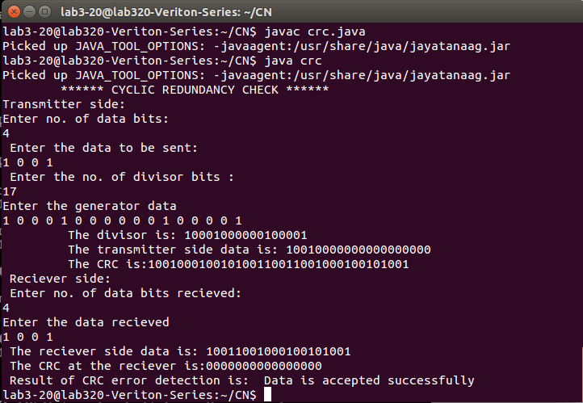

**8. Write a program to find the shortest path between vertices using bellman-ford algorithm**

Distance Vector Algorithm is a decentralized routing algorithm that requires that each router simply inform its neighbours of its routing table. For each network path, the receiving routers pick the neighbour advertising the lowest cost, then add this entry into its routing table for re-advertisement. To find the shortest path, Distance Vector Algorithm is based on one of two basic algorithms: Bellman-Ford and Dijkstra algorithms. Routers that use this algorithm have to maintain the distance tables (which is a one- dimension array -- "a vector"), which tell the distances and shortest path to sending packets to each node in the network. The information in the distance table is always up date by exchanging information with the neighbouring nodes. The number of data in the table equals to that of all nodes in networks (excluded itself). The columns of table represent the directly attached neighbours whereas the rows represent all destinations in the network. Each data contains the path for sending packets to each destination in the network and distance/or time to transmit on that path (we call this as "cost"). The measurements in this algorithm are the number of hops, latency, the number of outgoing packets, etc. The Bellman–Ford algorithm is an algorithm that computes shortest paths from a single source vertex to all of the other vertices in a weighted digraph. It is slower than Dijkstra's algorithm for the same problem, but more versatile, as it is capable of handling graphs in which some of the edge weights are negative numbers. Negative edge weights are found in various applications of graphs, hence the usefulness of this algorithm. If a graph contains a "negative cycle" (i.e. a cycle whose edges sum to a negative value) that is reachable from the source, then there is no cheapest path: any path that has a point on the negative cycle can be made cheaper by one more walk around the negative cycle. In such a case, the Bellman–Ford algorithm can detect negative cycles and report their existence.

**Source Code:**

import java.util.Scanner;

public class BellmanFord

{

private int distances[];

private int nv;

public static final int MAX_VALUE = 999;

public BellmanFord(int nv)

{

this.nv= nv;

distances = new int[nv+1];

}

public void BellmanFordEvaluation(int source,int adm[][])

{

for(int node=1;node<=nv;node++)

{

distances[node]=MAX_VALUE;

}

distances[source]=0;

for(int node=1;node<=nv-1;node++)

{

for(int sn=1;sn<=nv;sn++)

{

for(int dn=1;dn<=nv; dn++)

{

if(adm[sn][dn]!=MAX_VALUE)

{

if(distances[dn]>distances[sn] + adm[sn][dn])

distances[dn]=distances[sn]+adm[sn]

[dn];

}

}

}

}

for (int sn=1;sn<=nv;sn++)

{

for(int dn=1;dn<=nv; dn++)

{

if(adm[sn][dn]!=MAX_VALUE)

{

if(distances[dn]>distances[sn] + adm[sn][dn])

System.out.println("The graph contains negative edge cycle");

}

}

}

for(int vertex=1;vertex<=nv;vertex++)

{

System.out.println("Distance of source "+source+" to "+vertex+" is "+distances[vertex]);

}

}

public static void main(String args[])

{

int nv=0;

int source, destination;

Scanner scanner = new Scanner(System.in);

System.out.println("Enter the number of vertices");

nv=scanner.nextInt();

int adm[][]= new int[nv+1][nv+1];

System.out.println("Enter the adjacency matrix");

for(int sn=1;sn<=nv;sn++)

{

for(int dn=1;dn<=nv; dn++)

{

adm[sn][dn]=scanner.nextInt();

if(sn==dn)

{

adm[sn][dn]=0;

continue;

}

if(adm[sn][dn]==0)

{

adm[sn][dn]=MAX_VALUE;

}

}

}

System.out.println("Enter the source vertex");

source=scanner.nextInt();

BellmanFord bellmanford = new BellmanFord(nv);

bellmanford.BellmanFordEvaluation(source,adm);

}

}

**Output:**

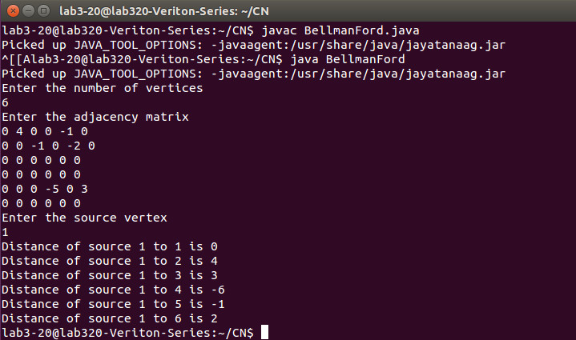

**9. Using TCP/IP sockets, write a client – server program to make the client send the file name and to make the server send back the contents of the requested file if present.**

Socket is an interface which enables the client and the server to communicate and pass on information from one another. Sockets provide the communication mechanism between two computers using TCP. A client program creates a socket on its end of the communication and attempts to connect that socket to a server. When the connection is made, the server creates a socket object on its end of the communication. The client and the server can now communicate by writing to and reading from the socket.

**Source Code:**

**Server Program:**

import java.net.*;

import java.io.*;

public class Cserver

{

public static void main(String args[]) throws Exception

{

ServerSocket sersock = new ServerSocket(4000);

System.out.println("Server ready for connection ");

Socket sock = sersock.accept();

System.out.println("Connection is successful and waiting for chatting");

InputStream istream = sock.getInputStream();

BufferedReader fileRead = new BufferedReader (new InputStreamReader(istream));

String fname = fileRead.readLine();

BufferedReader contentRead = new BufferedReader (new FileReader(fname));

OutputStream ostream = sock.getOutputStream();

PrintWriter pwrite = new PrintWriter (ostream,true);

String str;

while((str=contentRead.readLine())!=null)

{

pwrite.println(str);

}

sock.close();

sersock.close();

pwrite.close();

fileRead.close();

contentRead.close();

}

}

**Client Program:**

import java.io.*;

import java.net.*;

public class Client

{

public static void main(String[] args) throws Exception

{

Socket sock = new Socket("127.0.0.1",4000);

System.out.println("Enetr the file name");

BufferedReader keyRead = new BufferedReader(new InputStreamReader(System.in));

String fname = keyRead.readLine();

OutputStream ostream = sock.getOutputStream();

PrintWriter pwrite = new PrintWriter(ostream,true);

pwrite.println(fname);

InputStream istream = sock.getInputStream();

BufferedReader socketRead = new BufferedReader(new InputStreamReader (istream));

String str;

while((str=socketRead.readLine())!=null)

{

System.out.println(str);

}

pwrite.close();

socketRead.close();

keyRead.close();

}

}

**Output:**

**Server Side**

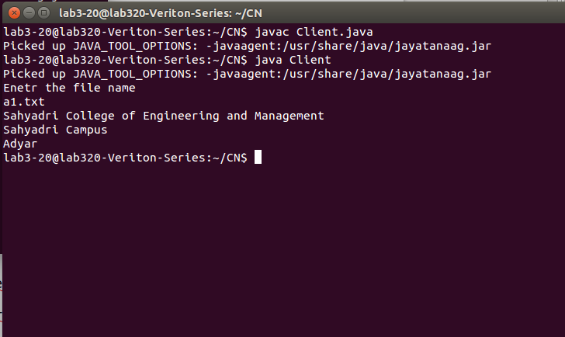

**Client Side**:

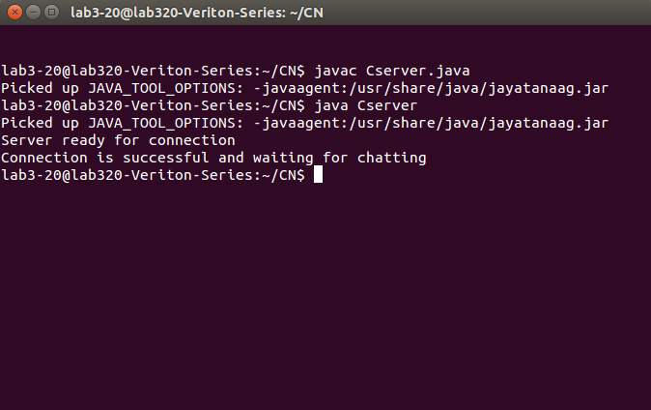

**10. Write a program on datagram socket for client/server to display the messages on client side, typed at the server side.**

A datagram socket is the one for sending or receiving point for a packet delivery service. Each packet sent or received on a datagram socket is individually addressed and routed. Multiple packets sent from one machine to another may be routed differently, and may arrive in any order.

**Source Code:**

import java.net.*;

class WriteServer

{

public static int serverPort = 1150;

public static int clientPort = 1160;

public static int buffer_size =1024;

public static DatagramSocket ds;

public static byte buffer[] = new byte[buffer_size];

public static void TheServer() throws Exception

{

int pos=0;

while(true)

{

int c = System.in.read();

switch(c)

{

case -1: System.out.println("Server Quits");

return;

case '\r':break;

case '\n':ds.send(new DatagramPacket(buffer,pos,InetAddress.getLocalHost(),clientPort));

pos=0;

break;

default:buffer[pos++]=(byte) c;

}

}

}

public static void TheClient() throws Exception

{

while(true)

{

DatagramPacket p = new DatagramPacket(buffer,buffer.length);

ds.receive(p);

System.out.println(new String (p.getData(),0,p.getLength()));

}

}

public static void main(String args[]) throws Exception

{

if(args.length==1)

{

ds = new DatagramSocket(serverPort);

TheServer();

}

else

{

ds = new DatagramSocket(clientPort);

TheClient();

}

}

}

**OUTPUT:**

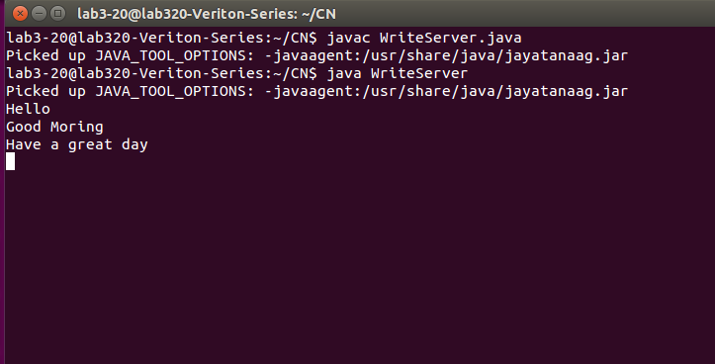

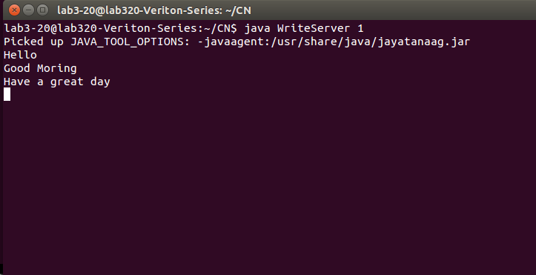

**11. Write a program for simple RSA algorithm to encrypt and decrypt the data.**

RSA is an example of public key cryptography. It was developed by Rivest, Shamir and Adelman. The RSA algorithm can be used for both public key encryption and digital signatures. Its security is based on the difficulty of factoring large integers. The RSA algorithm's efficiency requires a fast method for performing the modular exponentiation operation. A less efficient, conventional method includes raising a number (the input) to a power (the secret or public key of the algorithm, denoted *e* and *d*, respectively) and taking the remainder of the division with *N*. A straight-forward implementation performs these two steps of the operation sequentially: first, raise it to the power and second, apply modulo. The RSA algorithm comprises of three steps, which are depicted below:

**Key Generation Algorithm**

1. Generate two large random primes, p and q, of approximately equal size such that their product n = p*q

2. Compute n = p*q and Euler‘s totient function (φ) phi(n) = (p-1)(q-1).

3. Choose an integer e, 1 < e < phi, such that gcd(e, phi) = 1.

4. Compute the secret exponent d, 1 < d < phi, such that e*d ≡ 1 (mod phi).

5. The public key is (e, n) and the private key is (d, n). The values of p, q, and phi should also be kept secret.

**Encryption**

Sender A does the following:-

1. Using the public key (e,n)

2. Represents the plaintext message as a positive integer M

3. Computes the cipher text C = M^e mod n. 4. Sends the cipher text C to B (Receiver).

**Decryption**

Recipient B does the following:-

1. Uses his private key (d, n) to compute M = C^d mod n.

2. Extracts the plaintext from the integer representative m.

**Source Code:**

import java.util.*;

import java.io.*;

class rsa

{

static int mult(int x,int y,int n)

{

int k=1;

int j;

for (j=1; j<=y; j++)

k = (k * x) % n;

return ( int) k;

}

public static void main (String arg[])throws Exception

{

Scanner s=new Scanner(System.in);

InputStreamReader r=new InputStreamReader(System.in);

BufferedReader br=new BufferedReader(r);

String msg1;

int pt[]=new int[100];

int ct[]=new int[100];

int a,b, n, d, e,Z, p, q, i,temp,et;

System.out.println("Enter prime No.s p,q :");

p=s.nextInt();

q=s.nextInt();

n = p*q;

Z=(p-1)*(q-1);

System.out.println("\nSelect e value:");

e=s.nextInt();

System.out.printf("Enter message : ");

msg1=br.readLine();

char msg[]=msg1.toCharArray();

for(i=0;i<msg.length;i++)

pt[i]=msg[i];

for(d=1;d<Z;++d)

if(((e*d)%Z)==1) break;

System.out.println("p="+""+p+"\tq="+q+"\tn="+n+"\tz="+Z+"\te="+e+"\td="+d);

System.out.println("\nCipher Text = ");

for(i=0; i<msg.length; i++)

ct[i] = mult(pt[i], e,n);

for(i=0; i<msg.length; i++)

System.out.print("\t"+ct[i]);

System.out.println("\nPlain Text = ");

for(i=0; i<msg.length; i++)

pt[i] = mult(ct[i], d,n) ;

for(i=0; i<msg.length; i++)

System.out.print((char)pt[i]);

}

}

**OUTPUT:**

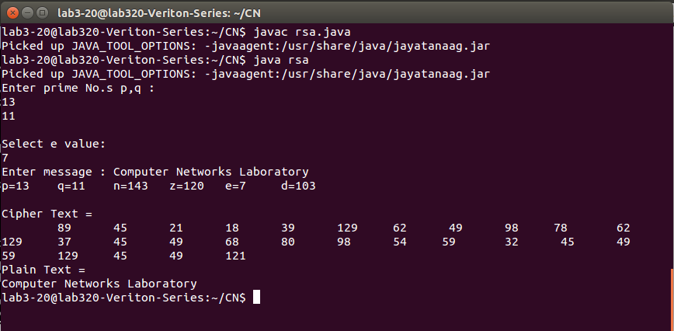

**12. Write a program for congestion control using leaky bucket algorithm.**

The main concept of the leaky bucket algorithm is that the output data flow remains constant despite the variant input traffic, such as the water flow in a bucket with a small hole at the bottom. In case the bucket contains water (or packets) then the output flow follows a constant rate, while if the bucket is full any additional load will be lost because of spill over. In a similar way if the bucket is empty the output will be zero. From network perspective, leaky bucket consists of a finite queue (bucket) where all the incoming packets are stored in case there is space in the queue, otherwise the packets are discarded. In order to regulate the output flow, leaky bucket transmits one packet from the queue in a fixed time (e.g. at every clock tick). In the following figure we can notice the main rationale of leaky bucket algorithm, for both the two approaches (e.g. leaky bucket with water (a) and with packets (b)).

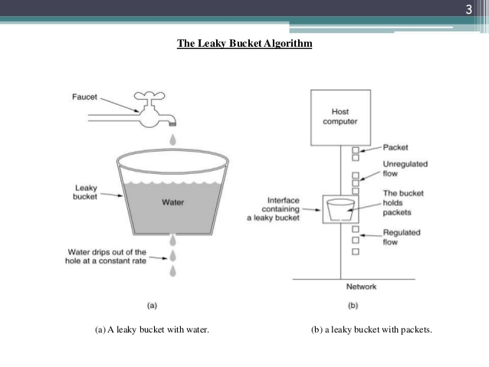

While leaky bucket eliminates completely bursty traffic by regulating the incoming data flow its main drawback is that it drops packets if the bucket is full. Also, it doesn‘t take into account the idle process of the sender which means that if the host doesn‘t transmit data for some time the bucket becomes empty without permitting the transmission of any packet.

**Source Code:**

import java.io.*;

import java.util.Scanner;

class Leaky

{

public static int min(int x,int y)

{

if(x<y)

return x;

else

return y;

}

public static void main(String args[])

{

Scanner sc=new Scanner(System.in);

int drop=0,mini,n,cap,count=0,i;

int inp[ ]= new int[25];

int process;

System.out.println("Enter The Bucket Size\n");

cap=sc.nextInt();

System.out.println("Enter The Output Rate\n");

process=sc.nextInt();

System.out.println("Enter the number of packets\n");

n=sc.nextInt();

System.out.println("Enter the size of packets to be sent:");

for(i=0;i<n;i++)

{

inp[i]=sc.nextInt();

}

System.out.println("\nSecond|Packet Recieved|Packet Sent|PacketLeft|Packet Dropped|\n");

System.out.println("--------------------------------------------------------------\n");

for(i=0;i<n;i++)

{

count+=inp[i];

if(count>cap)

{

drop=count-cap;

count=cap;

}

System.out.print(i+1);

System.out.print("\t" +inp[i]);

mini=min(count,process);

System.out.print("\t\t" + mini);

count=count-mini;

System.out.print("\t\t" +count);

System.out.println("\t\t"+ drop);

drop=0;

}

for(;count!=0;i++)

{

if(count>cap)

{

drop=count-cap;

count=cap;

}

System.out.print(i+1);

System.out.print("\t0");

mini=min(count,process);

System.out.print("\t\t" +mini);

count=count-mini;

System.out.print("\t\t" +count);

System.out.println("\t\t" +drop);

}

}

}

**OUTPUT:**

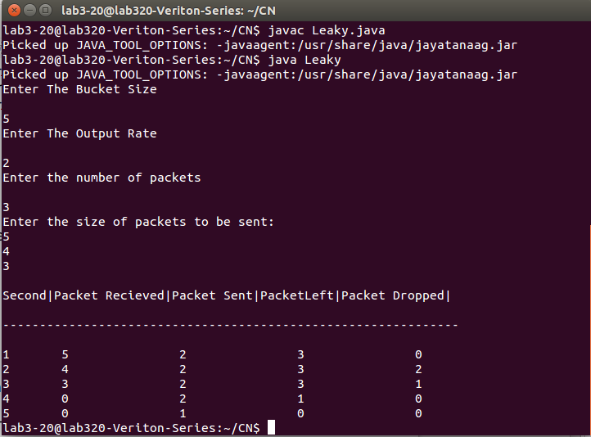

hello world